Talent that drives business results
Hiring people with IDD yields multiple dividends, including the addition of highly motivated employees, demonstrating an inclusive and diverse culture that’s attractive to critical talent pools and improves customer satisfaction.

*Straightforward employment packages
The Arc Eastern Connecticut tailors each employment package –from individual employees to supervised groups--to meet the specific needs of your company. Job profile matching and guided onboarding are readily available.

*Working Job Coach
Each group or individual is paired with a job coach who provides onsite support and is a liaison between the employee, the employer and The Arc’s administrative team.
Did You Know . . .
--Talent shortage is among the top 10 critical human capital issues for 2019.
--Improving the productivity of the workforce is the top priority for organizations, cited by 78% of high-performance organizations of 1,000 employees or more.

The Arc Eastern Connecticut’s Employment program serves people with IDD ages 16 and up throughout eastern Connecticut, providing Group and Individual Supported Employment, Transitional Services for students and adults, and Day programs.

*Tax Credits and Incentives
You may be eligible for significant tax credits and incentives when you hire an individual with IDD.

*No Overhead
When your business supports a group of employees, The Arc takes care of Worker’s Compensation, training costs and transportation.

*Great Publicity
The Arc will promote your company in newsletters, social media, our website, press releases and articles, and our Annual Report.

Find out more about how your business can benefit from hiring employees with intellectual and developmental disabilities.

In the Northeast: Call Jennifer Ricci, Director of Transitional and Employment Services, at (860) 928-4727.

In the Southeast: Call Bonnie Jones, Director of Business Development and Transition at (860) 449-1529 x 301.
TheArcECT.org

1

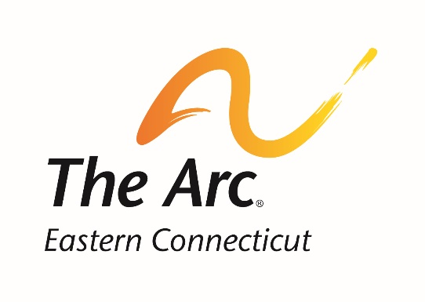
Our Employment Partners
in eastern Connecticut
The Arc ECT is proud to partner
with employers committed to
Real Work for Real Pay
at minimum wage or higher

B.J.’s Wholesale Club
Burnett’s Landscaping
CW Resources—The US Naval Submarine Base
Camp Harkness
DDS, Norwich
DXC Technology
Fleet Reserve Association
Gemma E. Moran United Way Food Center
Groton Marriott
Heritage Pines Condos
Holiday Inn of Norwich
Horses Healing Humans/Stonington Bed & Breakfast
Local Creations at Groton Senior Center
Lowe’s Distribution Center Plainfield
Mike Smith Transmissions
Mohegan Sun
New London Library
Rawson Materials
The Resident newspaper
Rite-Aid
Seely-Brown Village
ShopRite New London
Stop & Shop – Groton and Waterford
The 100th Aviation and Repair Depot (AVCRAD)
Walmart Brooklyn and Putnam
Waterford Community Center
Whitcraft

Employment opportunities in both Group-Supported and Individual-Supported Employment, combined with cutting-edge projects and microbusinesses, generate employment opportunities in the following fields:
* Culinary Arts
* Agriculture/Aquaponics
* Retail
* Cleaning/Hospitality
* Landscaping
* Recycling
The Arc Eastern Connecticut
Main Offices:
125 Sachem St.
Norwich, CT 06360 (860) 889-4435
TheArcECT.org
“I challenge corporations worldwide to hire people with intellectual or developmental disabilities.”
Anthony Kennedy Shriver
Founder and Chairman
Best Buddies International

